A

PROJECT REPORT

ON

**Flight Booking System**

Towards partial fulfillment of the requirement in

**2nd Semester** **BCA 2021**

**Submitted By: -**

200510101159 **-** Aman Kumar Singh

200510101164 **-** Roshani Singh

200510101169 **-** Mitanshi Solanki

**Submitted To:-**



**Parul Institute of Computer Application,**

**Parul University.**

Under the Guidance of

Prof. Manish Joshi **(**Assistant Professor**)**

**Acknowledgement**

*The success and final outcome of this project required a lot of guidance and assistance from many people and we are extremely privileged to have got this all along the completion of our project. All that we have done is only due to such supervision and assistance and we would not forget to thank them.*

*I respect and thank Dr. Priya Swaminarayan, Dean, FITCS for providing us an opportunity to do the project work in BCA and giving us all support and guidance which made us complete the project duly. We are extremely thankful to Mam for providing her support and guidance, although she had busy schedule managing the academic affairs.*

*We would not forget to remember Prof. Hina Chokshi, HOD, BCA department for her encouragement and more over for her timely support and guidance till the completion of our project work.*

*We owe our deep gratitude to our project guide* ***Prof. Manish Joshi****, who took keen interest on our project work and guided us all along, till the completion of our project work by providing all the necessary information for developing a good system.*

*We are thankful to and fortunate enough to get constant encouragement, support and guidance from our Parents, all Teaching staffs and specially to* ***Prof. Bhavika Vaghela*** *of BCA Department which helped us in successfully completing our project work. Also, we would like to extend our sincere esteems to all staff in laboratory for their timely support.*

***[Aman Kumar Singh] [200510101159]***

***[Roshani Singh] [200510101164]***

***[Mitanshi Solanki] [200510101169]***



**PARUL INSTITUTE OF COMPUTER APPLICATION**

**CERTIFICATE**

This is to certify that **Aman Kumar Singh, Roshani Singh, Mitanshi Solanki** the student(s) of Parul Institute of Computer Application, has/have satisfactorily completed the project entitled **“Flight Booking System”** as a part of course curriculum in BCA semester-II for the academic year 2021 under guidance of **Prof. Manish Joshi (Assistant Professor)**

Enrollment Number: **200510101159**

Enrollment Number: **200510101164**

Enrollment Number: **200510101169**

|  |  |  |
| --- | --- | --- |
| **Quality of work** | **Grade** | **Sign of Internal guide** |
| **Poor / Average / Good /**  **Excellent** | **B /B+ / A / A+** |  |

Date of submission:

HOD, Principal,

Prof. Hina Chokshi Dr. Priya Swaminarayan

**INDEX**

|  |
| --- |
| **Content** **Page No.** |
| 1. Introduction to Project System 06 |
| 1. System Requirement Specification 07 |
| * 1. Introduction to SRS 07 |
| * 1. Hardware Requirement 07 |
| * 1. Software Requirement 07 |
| * 1. System Users 08 |
| * 1. Description of User Role 08 |
| * 1. System Features 08 |
| * 1. Description of Features 09 |
| * 1. Timeline Chart 10 |
| 1. System Flow Diagram 11 |
| 1. Data Dictionary 12 |
| 1. Screenshots of Development Phase -1 16 |
| 1. Screenshots of Development Phase -2 18 |
| 1. Screenshots of Development Phase -3 21 |
| 1. Conclusion 24 |
| 1. Future Enhancement 25 |
| 1. References 26 |

**ABSTRACT**

In this System, we are providing features like View Flight Details, Add Flight Details, Delete Flight Details, Update Flight Details. Also features like Book Ticket and Delete booked Ticket features are there in this System. In this system Python language is used as front-end and Microsoft SQL is used as back-end. In this System there is Simple GUI with some Guidelines which is easily understand by any user.

This system is Password protected, So authorized user can only access to this system. In this system colorful texts are used which looks attractive.   
There are total three users in this system (Admin, Client and Visitor)  
Every user has their specific role in this System. For login into Admin and Client portal Password is Required and Visitor can login without any Password.  
This System will be very beneficial in Booking Ticket due to its Simple user interference and Permanent Data storing.

**Chapter: 01**

**INTRODUCTION**

Flight Booking System is the system which is developed using **Python** Programming Language and Microsoft SQL Server.

This system will be helpful in Booking Ticket and Managing Flights.

This system will be having some guidelines like System is totally case sensitive, when system will ask for any choices then input your choice very carefully otherwise it will give error. Also when you delete or modify any data then give your input carefully and which already exist. Let’s take an example to understand it better, when you are going to delete any previously booked Ticket then system will ask for Name and Mobile number of existing Ticket and if you enter anything which is not existed then the System will fire an error and the program will have closed. So be careful when you Modify/Delete Flight details or when you Delete any Booked Ticket Details.

For login to Admin and Client Portal System will ask for password but if you login to Visitor portal then there is no need of password. Every user has their Specific Task such as Admin having the access of view Flight details, Add Flight details, Edit Flight details, Delete Flight details, View Ticket details and Delete Ticket details. Client can only Book Tickets and View Flight details. Visitor can only access to view Flight details.

Another interesting feature is that Passenger can choose their Ticket class type such as (Standard Class, Economy Class, Business Class and First Class) when you will book Ticket.

For Booking Ticket System will ask for Name, Mobile Number, Last four digit of Aadhar Number, Age, Destination Point and Departure Point and then gives a Confirmation message that Ticket is Booked successfully and Show your Credentials.

**Chapter 2**

**System Requirement Specification**

**2.1 Introduction to SRS**

**2.1.1 What is SRS?**

A software requirements specification (SRS) is a description of a software system to be developed. It lays out functional and non-functional requirements, and may include a set of use cases that describe user interactions that the software must provide.

**2.1.2 Need of SRS**

In order to fully understand one’s project, it is very important that they come up with a SRS listing out their requirements, how are they going to meet it and how will they complete the project. It helps the team to save upon their time as they are able to comprehend how are going to go about the project. Doing this also enables the team to find out about the limitations and risks early on.

**2.2 Hardware Requirement**

|  |  |
| --- | --- |
| **Hardware Components** | **Specification** |
| Processor | Intel core I3,/I5 |
| RAM | 4GB/8GB |
| Hard disk or **SSD** | 512GB/1TB or **256GB** |
| Monitor | 15.6 colour monitor or advance |
| Device | Keyboard, Mouse |

**2.3 Software Requirement**

|  |  |
| --- | --- |
| **Name of component** | **Specification** |
| Operating System | WindowsXP,windows10 |
| Software development kit | Python Version 3 or above, Python IDLE/ Pycharm /VS code/ MSSQL/MySQL |
| Programming language | Python Programming [with Django( if required)] and Microsoft SQL |

**2.4 System Users**

2.4.1 Admin

2.4.2 Client

2.4.3 Visitor

**2.5 Description of User Role**

**2.5.1 Admin**

Admin can Add/Update/Delete Flight Details and It can also Delete Flight Booked Ticket’s. It can view both flight and ticket details.

* + 1. **Client**

Client can Book Flight Ticket and view flight details.

* + 1. **Visitor**

Visitor can only view the Flight Details.

**2.6 System Features**

1. **Guidelines**
2. **Login**
3. **View Flight Details**
4. **Add Flight Details**
5. **Edit Flight Details**
6. **Delete Flight Details**
7. **View Ticket Details**
8. **Book Flight Ticket**
9. **Delete Flight Ticket**

**2.7 Description of Features**

**2.7.1 Guidelines**

System provides some Guidelines; it helps user in using this System.

**2.7.2 Login**

System having 3 predefined users which is Admin, Client and Visitors. Admin and Client portal required password’s but visitor portal doesn’t required password for login. System will ask for username for all portal but it ask password from only Admin and Client Portal.

**2.7.2 View Flight Details**

Every three users of this System has access to view all the Flight details.

**2.7.3 Add Flight Details**

In this System Admin Can Login and then Add Flight details. System will ask for Flight ID, Departure Point and Destination Point details for adding Flights.

**2.7.4 Edit Flight Details**

Admin has the access to edit Flight details, for that system will ask for existing Flight ID and then it will ask for New Departure Point and New Destination Point. One important note, if user will enter invalid Flight ID which is not existing then It will fire and error and Program will be Closed.

**2.7.5 Delete Flight Details**

Admin has the access to delete Flight details, for that system will ask for existing Flight ID and the details of that Flight will be Deleted. Same here if you input wrong Flight ID, system will fire error and Program will be Closed.

**2.7.5 View Ticket Details**

Admin has the access to view Ticket Details.

**2.7.7 Book Flight Ticket**

Client has only the access to book flight ticket, for that system will ask to select Class type like (Standard, Economy, Business, first… Class) and then ask for Mobile Number, Name, Departure Point, Destination Point, Age, Last four digit of Aadhar Number. After that it will give you a Confirmation message that your ticket is booked successfully and show your Ticket.

**2.7.8 Delete Flight Ticket**

Admin has the access to Delete the Booked Ticket. For that system will ask for existed Phone Number and Name and then it gives a message that Ticket Deleted Successfully.

**2.8 Timeline Chart**

|  |  |  |  |  |  |  |  |
| --- | --- | --- | --- | --- | --- | --- | --- |
| **Development phase** | ***75 Days*** | | | | | | **Duration**  **N**  **(days)** |
| 0to10 days | 11to20  days | 21to30 days | 31to40 days | 41to50 days | 51to75  days |
| **Requirement**  **Gathering** |  |  |  |  |  |  | 07 |
| **Analysis** |  |  |  |  |  |  | 09 |
| **Design** |  |  |  |  |  |  | 10 |
| **Development Phase 1** |  |  |  |  |  |  | 13 |
| **Development Phase 2** |  |  |  |  |  |  | 13 |
| **Development Phase 3** |  |  |  |  |  |  | 13 |
| **Documentation** |  |  |  |  |  |  | 10 |
| **Total time**  **(Days)** |  | | | | | | **75** |

2.8Time line chart of Flight Booking System

**Chapter 3**

**System Flow Diagram**

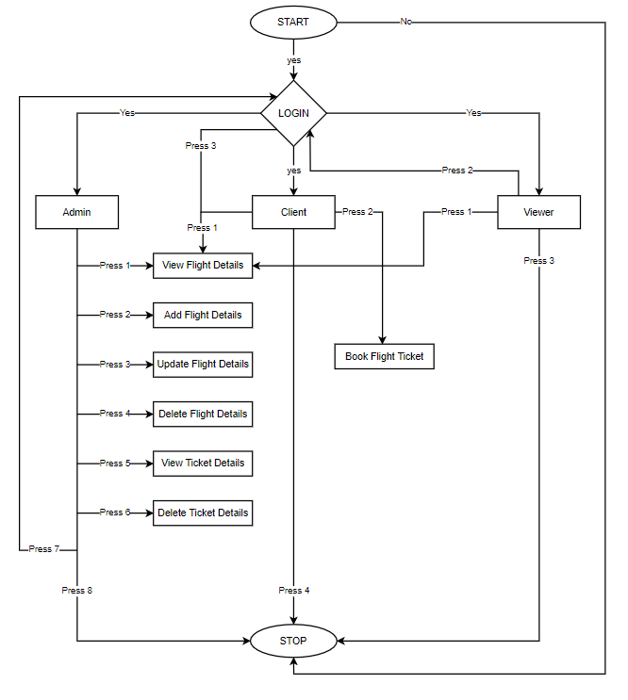Figure 1 System Flow Diagram of Flight Booking System

**Chapter 4**

**Data Dictionary**

**4.1 Login Table**

In this Table Program will ask the User to input correct Username and Password for Login into the System.

|  |  |  |  |  |  |  |
| --- | --- | --- | --- | --- | --- | --- |
| **Sr. No.** | **Field Name** | **Data Type** | **Size** | **Constraint** | **Description** | **Example** |
| 1. | Username | varchar | 10 | Primary Key | Unique id of Username | admin |
| 2. | Password | varchar | 10 |  | Unique id of Password | admin |

Table 4.1 Login Table

**4.2 Add Flight Details**

In this Table Program will ask for Flight ID, Destination Point and Departure Point for Add Flight Details in the System.

|  |  |  |  |  |  |  |
| --- | --- | --- | --- | --- | --- | --- |
| **Sr. No.** | **Field Name** | **Data Type** | **Size** | **Constraint** | **Description** | **Example** |
| 1. | Flight ID | Varchar | 10 | Primary Key | Unique flight ID | AIRINDIA101 |
| 2. | Departure Point | Varchar | 10 |  | It will ask for Departure Point | Pune |
| 3. | Destination Point | Varchar | 10 |  | It will ask for Destination Point | Vadodara |

Table 4.2 Add Flight Details

**4.3 Update Flight Details**

In this Table Program will ask for Flight ID, New Destination Point and New Departure Point for Updating Existing Flight Details.

|  |  |  |  |  |  |  |
| --- | --- | --- | --- | --- | --- | --- |
| **Sr. No.** | **Field Name** | **Data Type** | **Size** | **Constraint** | **Description** | **Example** |
| 1. | Flight_ID | Varchar | 10 | Primary Key | Unique existing flight ID | AIRINDIA101 |
| 2. | New Departure Point | Varchar | 10 |  | It will replace old Departure Point | DUBAI |
| 3. | New Destination Point | Varchar | 10 |  | It replace old Destination Point | MUMBAI |

Table 4.3 Update Flight Details

**4.4 Delete Flight Details**

In this Table Program will ask for Flight ID which should be already exist in the system for Delete that Flight Details from the System.

|  |  |  |  |  |  |  |
| --- | --- | --- | --- | --- | --- | --- |
| **Sr. No.** | **Field Name** | **Data Type** | **Size** | **Constraint** | **Description** | **Example** |
| 1. | Flight ID | Varchar | 10 | Primary Key | Unique flight ID that exists in System | AIRINDIA101 |

Table 4.4 Delete Flight Details

**4.5 Book Flight Ticket**

In this Table Program will ask for some details to Book your Ticket then give user a Confirmation message that your Ticket is Booked Successfully.

|  |  |  |  |  |  |  |
| --- | --- | --- | --- | --- | --- | --- |
| **Sr. No.** | **Field Name** | **Data Type** | **Size** | **Constraint** | **Description** | **Example** |
| 1. | Choose Class | Integer | 1 |  | Some options are given and User have to choose one | Press 4   * 4 |
| 2. | Phone Number | Integer | 10 |  | It will ask for 10 digit Mobile Number | 1234567890 |
| 3. | Name | Varchar | 30 |  | It will ask for Person Name | The Rock |
| 4. | Departure Point | Varchar | 10 |  | It will ask for point where Person will take his/her Flight. | New York |
| 5. | Destination Point | Varchar | 10 |  | It will ask for point where Person will have to GO. | Dubai |
| 6. | Age | Integer | 3 |  | It will ask for Person Age. | 18 |
| 7. | Last 4-digit of Aadhar Number | Integer | 4 |  | It will ask for Person Aadhar Number (Last 4-digit) | 5489 |

Table 4.5 Book Flight Ticket

**4.6 Delete Flight Ticket**

In this Table Program will ask Registered Phone Number and Name on Ticket should be already exist in the system for Delete that Flight Details from the System.

|  |  |  |  |  |  |  |
| --- | --- | --- | --- | --- | --- | --- |
| **Sr. No.** | **Field Name** | **Data Type** | **Size** | **Constraint** | **Description** | **Example** |
| 1. | Mobile Number | Integer | 10 |  | Existing Phone Number that is already Booked. | 1234567890 |
| 2. | Name | Varchar | 30 |  | Name which is registered with Phone Number mentioned above. | The Rock |

Table 4.6 Delete Flight Details

**Chapter 5**

**Screenshot of Development Phase 1**

**5.1 SQL Connection Design**

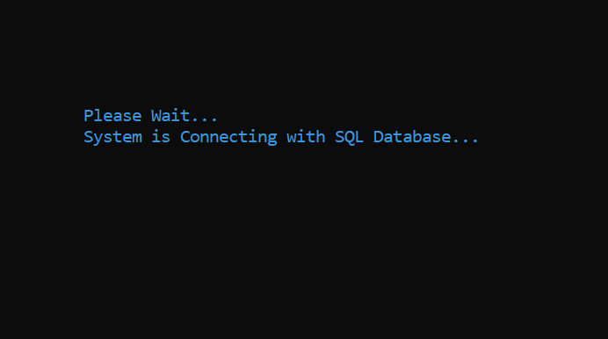 Figure 5.1 SQL Connection Design

**5.2 Code of SQL Connection**

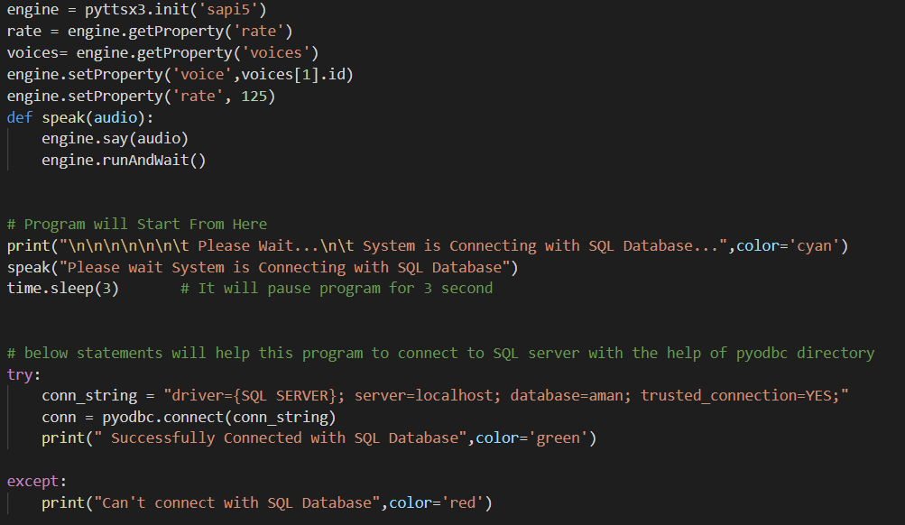

Figure 5.2 Code of SQL Connection

**5.3 Guideline Design**

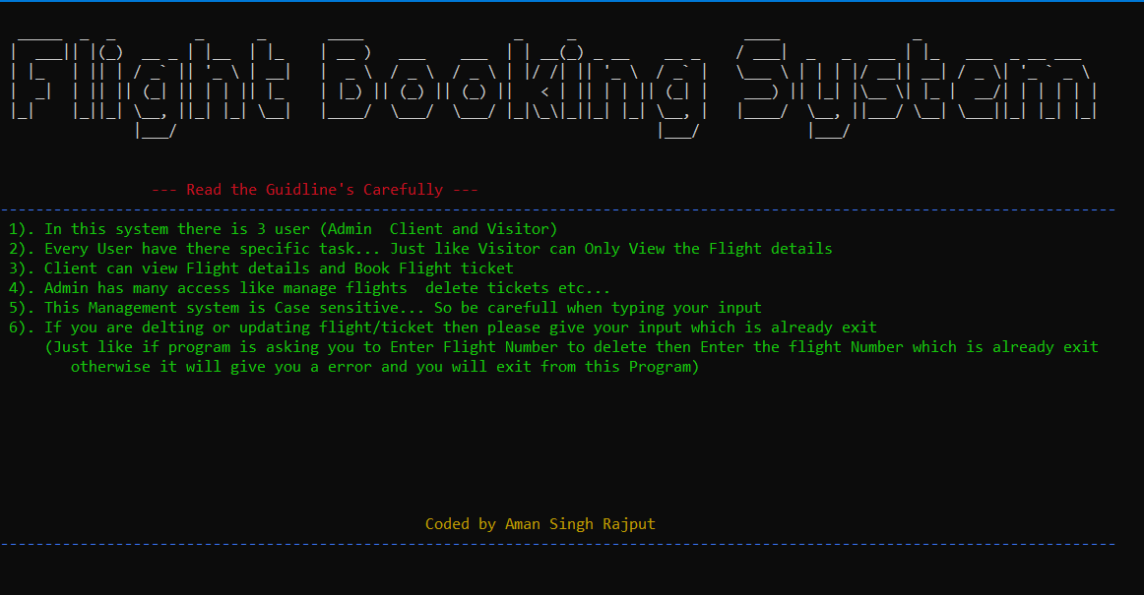

Figure 5.3 Guideline Design

**5.4 Code of Guideline**

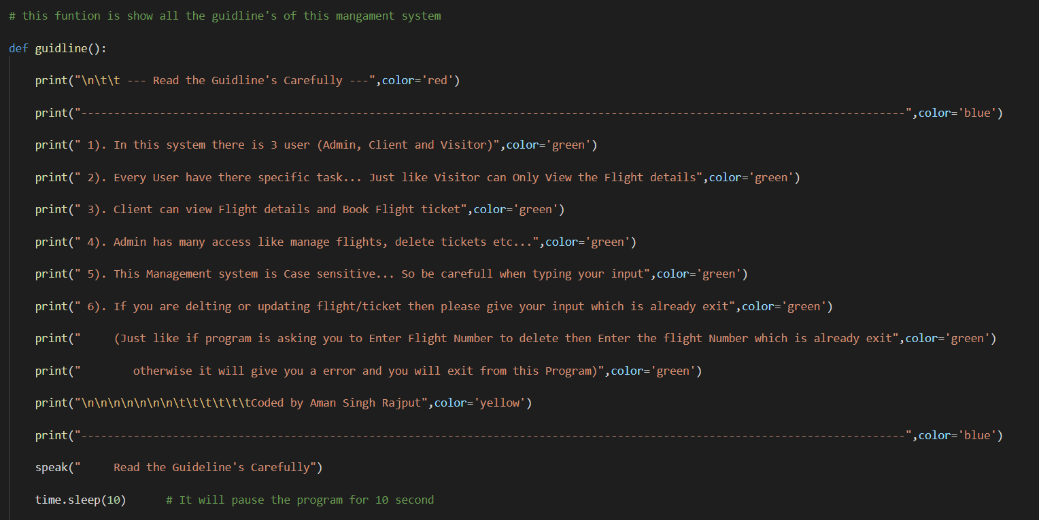

Figure 5.4 Code of Guideline

**Chapter 6**

**Screenshot of Development Phase 2**

**6.1 Admin Portal Design**

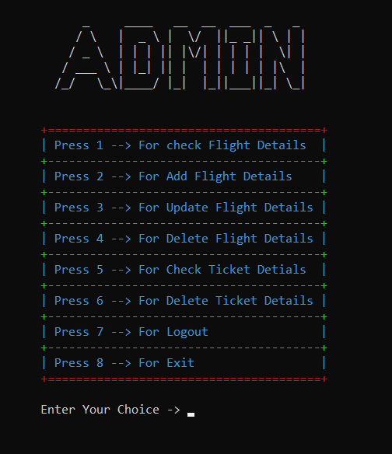

Figure 6.1 Admin Portal Design

**6.2 Admin Portal Code**

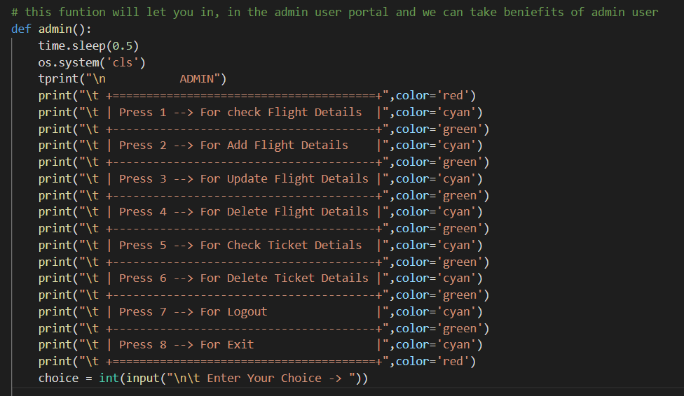

Figure 6.2 Admin Portal Code

**6.3 Client Portal Design**

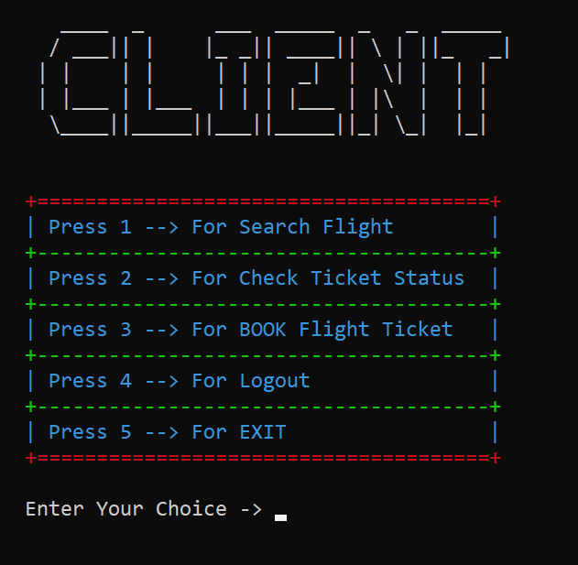

Figure 6.3 Client Portal Design

**6.4 Client Portal Code**

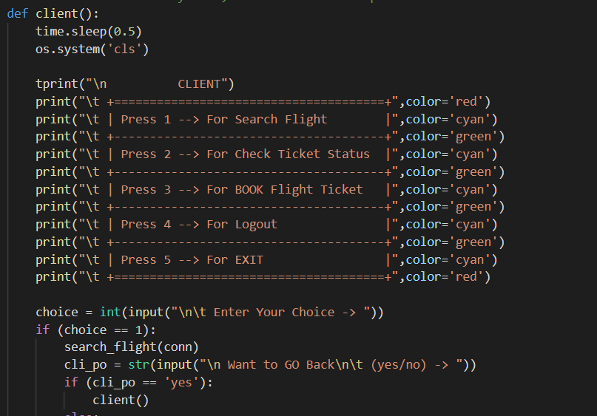

Figure 6.4 Client Portal Code

**6.5 Visitor Portal Design**

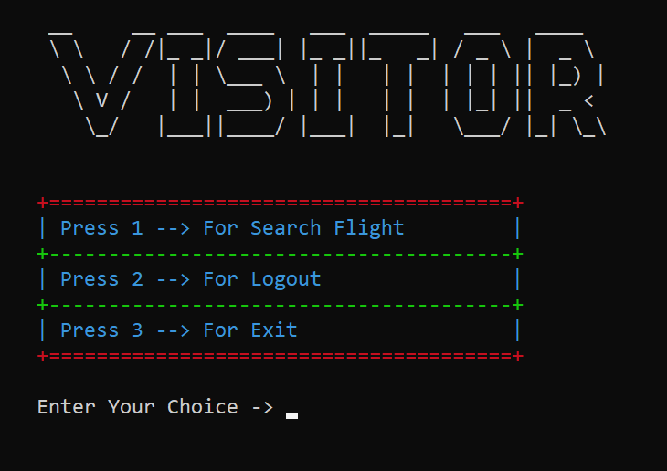

Figure 6.5 Visitor Portal Design

**6.6 Visitor Portal Code**

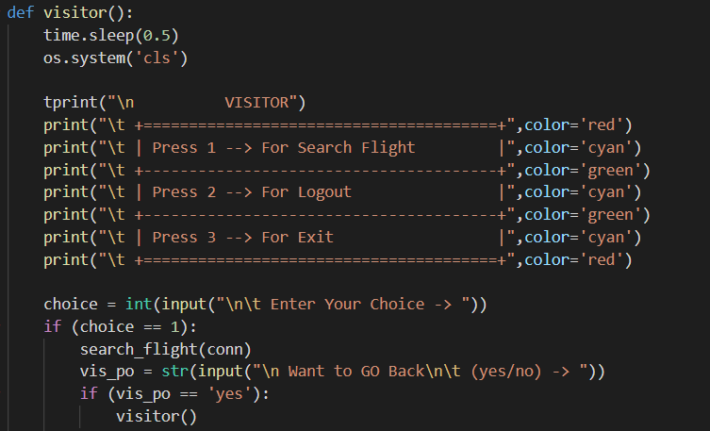

Figure 6.6 Visitor Portal Code

**Chapter 7**

**Screenshot of Development Phase 3**

**7.1 Ticket Booking Design**

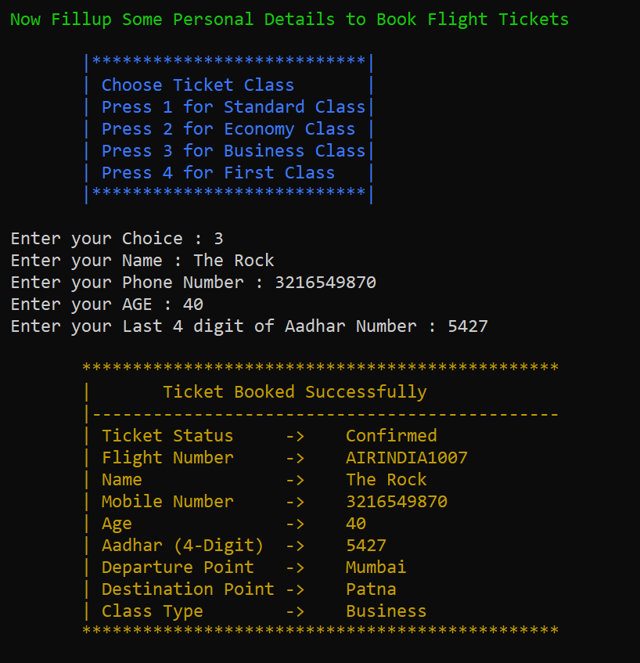

Figure 7.1 Ticket Booking Design

**7.2 Code of Ticket Booking**

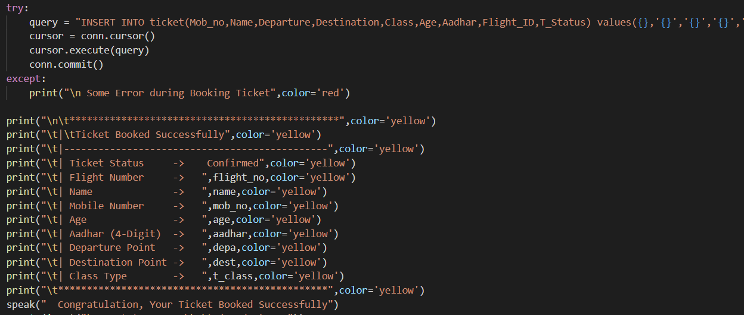

Figure 7.2 Code of Ticket Booking

**7.3 Flight Details Design**

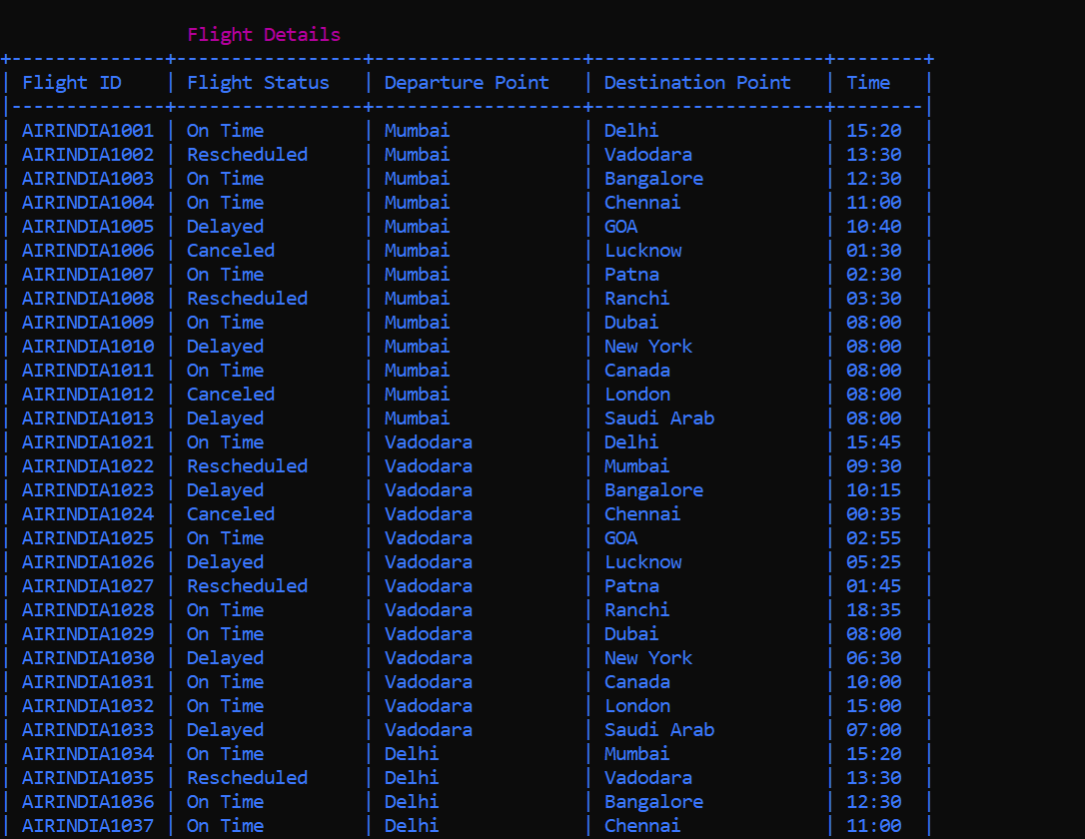

Figure 7.3 Flight Details Design

**7.4 Code of Flight Details**

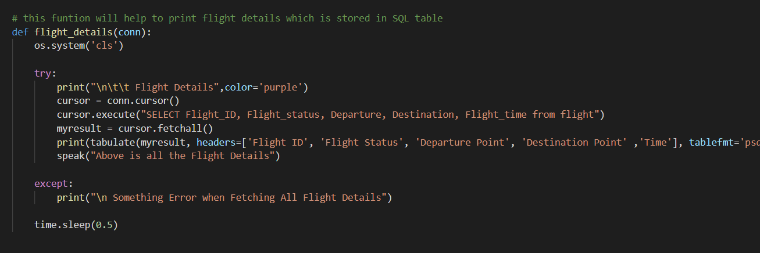

Figure 7.4 Code of Flight Details

**7.5 Searching of Flight Design**

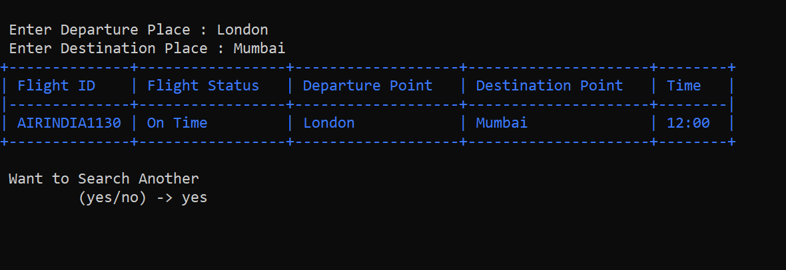

Figure 7.5 Searching of Flight Design

**7.6 Code of Searching of Flight**

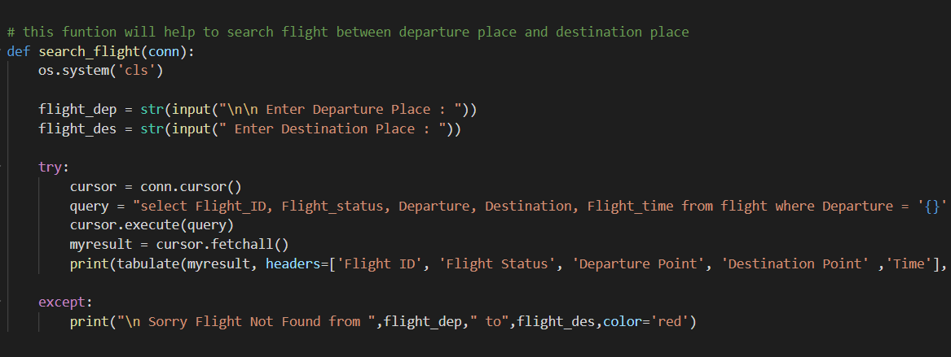

Figure 7.6 Code of Searching of Flight

**Chapter 8**

**Conclusion**

Our System Flight Booking System finally completed and runs with error free. At the time of developing this system we face a lot issue from starting but we didn’t stop and started finding of every problem.

Our First problem was to connect our system with SQL Server, and it takes a lot of time to solve. We also add some features that we don’t decided previously like Voice Command and Searching Ticket Status. Our system Provides a lot of features for every type of user.

Due to we use different types of color, our system looks beautiful and attractive and it attracts user. We also use some important modules of Python like Pyodbc that helps the system to Connect with SQL server that is main task. We try our best to make this system error free and we also tested our system more than 100 times and tried to solve and small issues. And we can proudly say that no there is no any error in Our System, there is only lack of some Features that we will add in Future.

**Chapter 9**

**Future Enhancement**

In future we will give a better Graphics that user can easily understand this system and it can be easily accessible.

We will also add voice recognizable feature that can easily help user to use this System and also in Booking Ticket.

There is disadvantage in Our System that is there is no limit of Booking Ticket, so in Future we will Limit the Booking of Ticket.

In Our system no other user can Register themselves, so we will also add this feature in Future.

The main Problem of our system is that SQL Server can’t connect in another device, for this we have to connect SQL Server with IP Address and we will implement this in Future.

Also this system is only made for Windows, Linux and MAC, so we can’t access it from our Smartphone and for that we will also do something that we can also use this system on the smartphone.

**Chapter 10**

**References**

Website:

1. <https://github.com/>
2. <https://stackoverflow.com/>
3. <https://www.quora.com/>
4. <https://docs.microsoft.com/en-us>
5. <https://www.geeksforgeeks.org/>
6. <https://www.khanacademy.org/>

Book:

1. Python for Everyone
2. SQL Beginners Guide

Other Resources:

1. Some Journals